
CONNECT BEYOND LIMITS
MODEL SPECIFICATION
Structured Cabling Design, Architecture,
Installation, Testing & Handover
Including Conventional Category 6 / Category 6A and
Hyperspan XR™ Extended-Reach Ethernet
DOCUMENT STATUS
Generic model specification for adoption within an organisation's structured-cabling standards, consultant design guides and project specifications. It defines a controlled route for conventional and extended-reach cabling but does not replace applicable law, published standards, product instructions or project-specific technical approval.

HSP-SCS-XR-SPEC-001 | Version 1.1 | 20 August 2026
Prepared by Hyperspan Data Ltd • www.hyperspan.net • Product catalogue

Document control
Field | Requirement / value
Document reference | HSP-SCS-XR-SPEC-001
Title | Structured Cabling Design, Architecture, Installation, Testing & Handover - Model Specification
Version / date | Version 1.1 / 20 August 2026
Status | Generic model specification for organisational adoption and project adaptation
Intended use | Corporate standards, consultant specifications, new-build and retrofit projects across enterprise, education, security/CCTV, smart building, industrial, campus and selected data-centre support applications
Project fields | Client: ____________________ Project: ____________________ Site: ____________________
Approval fields | Standards owner: ____________________ Approver: ____________________ Date: ____________________
Author | Hyperspan Data Ltd, 167-169 Great Portland Street, 5th Floor, London, W1W 5PF, United Kingdom

CORE TECHNICAL POSITION
Conventional Category 6 and Category 6A links remain governed by recognised generic-cabling length limits. Beyond that envelope, a technically eligible Hyperspan XR channel should be the design presumption where it avoids disproportionate repeaters, remote switches, cabinets, UPSs, local power or a new telecommunications room. Any decision to use a more complex active architecture instead shall be supported by a documented capacity, resilience, isolation, growth or lifecycle justification. XR remains an application-specific channel and shall be approved, labelled and tested as XR.

Official resources and contact
Hyperspan Data Ltd • 167-169 Great Portland Street, 5th Floor, London, W1W 5PF, United Kingdom • 0800 098 2789
Website • Product catalogue • Email sales • Email support • LinkedIn

How to use this model
- Adopt the policy clauses. Insert the conventional-versus-XR selection rule into the organisation's design standard, consultant brief, drawing notes, schedules and procurement templates.
- Require option appraisal. Every route beyond the adopted conventional length envelope shall compare XR with fibre, a remote active cabinet and a new telecommunications room on technical and whole-life grounds.
- Complete the project schedules. Insert the organisation, site, products, applications, environmental classifications and controlled test-profile versions before tender or construction.
- Obtain written technical approval. Where the existing standard has no XR process, complete the XR Design Approval Record in Appendix C before production installation.
- Use current manufacturer data. Product data sheets, CPR declarations, installation instructions, warranty conditions and test resources current at the date of procurement take precedence over catalogue summaries.
- Record every link. The as-built register must distinguish Cat 6, Cat 6A and XR circuits, including route length, application, PoE design basis and test method.

Contents
Section | Subject
1-3 | Purpose, compliance hierarchy, terminology and responsibilities
4-6 | Architecture, category selection and conventional copper requirements
7-8 | Hyperspan XR governance and application-specific guidance
9-11 | Pathways, installation, environment and remote powering
12-15 | Testing, administration, quality, handover and operational change
Appendix A | Design decision matrix
Appendix B | Hyperspan product schedule
Appendix C | XR Design Approval Record
Appendix D | Inspection and Test Plan
Appendix E | Close-out checklist
Appendix F | Model adoption clause and implementation checklist
Appendix G | Reference framework and source notes

1. Purpose, scope and status
This document defines a generic organisational standard for balanced copper structured cabling. It retains conventional Category 6 and Category 6A design within the recognised 90 m permanent-link and 100 m channel framework, and adds a controlled process for Hyperspan XR extended-reach channels beyond that envelope.
Its purpose is to let asset owners, architects, consultants and integrators incorporate extended reach into existing design processes without weakening standards governance. The required outcome is the least-complex whole-life architecture that satisfies the application, safety, capacity, environment, resilience, maintainability and growth requirements.

1.1 In scope
- Horizontal balanced copper cabling from telecommunications room or equipment distributor to work-area or service outlet.
- IP CCTV, wireless access points, access control, intercom, building management, sensors, IoT and other Ethernet/PoE endpoints.
- Small remote groups of endpoints where a new active cabinet or communications room may be disproportionate.
- New-build, refurbishment and retrofit design decisions where XR may reduce active hardware, local power, equipment space, energy use, maintenance demand, material quantity or installation programme.
- Indoor, outdoor, campus, industrial and temporary/deployable routes, subject to environment-specific cable and protection requirements.
- Design records, installation workmanship, testing, labelling, handover and subsequent change control.

1.2 Out of scope unless separately engineered
- Public telecommunications networks, carrier outside plant and utility-owned infrastructure.
- Life-safety, fire-alarm or emergency systems where applicable law or the approving authority requires a dedicated approved cabling method.
- Hazardous areas, railway traction environments, explosive atmospheres or other specialist locations without a separate engineered specification.
- Primary data-centre server/storage fabrics or any link requiring more bandwidth than the selected XR application profile supports.
- Building-to-building metallic links where electrical isolation, lightning exposure or earth-potential difference requires fibre.

2. Compliance hierarchy and organisational adoption

2.1 Order of precedence
The following order of precedence shall apply. A higher item shall override a lower item where requirements conflict:
1. Applicable law, building regulations, electrical rules, fire code, security law and requirements of the approving authority.
2. Project-specific employer's requirements, approved design and written departures.
3. Applicable editions of ISO/IEC, EN/BS EN and/or ANSI/TIA cabling standards identified in the project schedule.
4. This model specification and the approved XR Design Approval Record.
5. Current manufacturer data sheets, installation instructions, CPR declarations, test profiles and warranty terms.

2.2 Standards basis
Topic | Principal reference framework
Generic cabling | ISO/IEC 11801 series; BS EN 50173 series; ANSI/TIA-568 series
Planning and installation | ISO/IEC 14763-2; BS EN 50174 series; applicable national installation rules
Pathways and spaces | ANSI/TIA-569-E or applicable EN/ISO and project requirements
Administration and labelling | ANSI/TIA-606-D or equivalent client administration standard
Bonding and earthing | ANSI/TIA-607-E, ISO/IEC 30129 and applicable electrical regulations
Remote powering | IEEE 802.3 PoE application requirements; ISO/IEC TS 29125; ANSI/TIA TSB-184-A where adopted
Balanced-cabling field test | IEC 61935-1 / ANSI/TIA-1152 family, tester manufacturer instructions and the selected test limit
Fire performance | Applicable construction-product, fire and smoke rules; product-specific declaration and approved route

Standard editions shall be confirmed at project start and again before issue for construction. This document references standards but does not reproduce or replace them.

2.3 Incorporation into existing standards and processes
The organisation's existing structured-cabling standard remains the baseline for conventional links. XR shall be incorporated as a separate controlled link class with its own selection rule, drawings and schedules, approval record, test profile, labels, asset-register flag and change-control requirements. Adoption does not require the organisation to rewrite the underlying ISO/IEC, BS EN or ANSI/TIA framework.
- Add XR to architecture briefs, employer's requirements, consultant design guides, specifications, standard details and bills of quantities.
- Require the architect or lead consultant to identify routes beyond the conventional envelope during concept design, before remote rooms, power and containment are fixed.
- Require a documented XR/fibre/active option appraisal for every beyond-limit route or repeated endpoint type.
- Name the approved products, application envelope, contract test profile, warranty route and handover evidence in project schedules.
- Train operations teams to identify, test and alter XR channels under the approved process rather than as ordinary 90 m permanent links.
ORGANISATIONAL ADOPTION RULE
For a technically eligible low-to-moderate-density remote endpoint application, Hyperspan XR shall be the preferred design where it removes disproportionate repeaters, remote switches, cabinets, UPSs, local power, cooling or a new telecommunications room. Fibre or active distribution may still be selected where a documented appraisal demonstrates a stronger requirement for bandwidth, port density, electrical isolation, resilience, expansion or service concentration.

3. Terms, definitions and responsibilities
Term | Definition for this specification
Permanent link | The installed fixed cabling between patch-panel and outlet test interfaces, excluding equipment and work-area cords.
Channel | The end-to-end passive copper path including fixed cable, connectors and patch/equipment cords.
Conventional link | A Category 6 or Category 6A link designed within the adopted standards-length topology.
XR link | A project-approved Hyperspan extended-reach channel designed and certified against the applicable Hyperspan application profile.
PSE / PD | Power sourcing equipment / powered device under the relevant PoE application.
Approving authority | The organisation's technical standards owner, client approver or statutory Authority Having Jurisdiction, as applicable.
MPTL | Modular Plug Terminated Link, used only where permitted by the adopted standard and project design.
TR / ER | Telecommunications room / equipment room.

3.1 Mandatory language
- Shall indicates a mandatory requirement.
- Should indicates a recommended practice; any departure should be documented.
- May indicates an allowed option requiring project judgement.
- Approved means accepted in writing by the designated organisational or project technical authority.

3.2 Responsibilities
Role | Minimum responsibility
Technical standards owner | Adopt the selection policy, approved application envelopes, testing, warranty, records and change-control requirements.
Architect / lead consultant | Identify beyond-limit routes early; coordinate space, containment and building services; require and review the XR/fibre/active option appraisal.
Cabling designer | Select topology and media; complete distance, capacity, PoE, environment, resilience, maintainability and lifecycle assessments.
Network designer | Confirm Ethernet rate, port configuration, PSE capability, redundancy and monitoring requirements.
Security / system designer | Confirm endpoint model, power, bandwidth, recording or control requirements and required authority approvals.
Cost / sustainability advisor | Compare active hardware, power, cooling, space, materials, maintenance, replacement and programme implications where the role forms part of the project.
Installer | Install only approved products and routes; protect cable performance; test, label and document every link.
Commissioning authority | Witness or review test evidence and confirm the installed application operates under design load.
Hyperspan technical support | Provide current product data, selection support, XR test resources and clarification of system requirements.

4. Structured cabling architecture

4.1 General topology
Horizontal cabling shall use a hierarchical star topology. Each endpoint shall be served by a dedicated point-to-point link from the serving distributor or switch. Daisy-chained outlets, passive Ethernet splitters and undocumented inline extenders shall not be used.
- Backbone and campus architecture shall normally use optical fibre where high bandwidth, distance, resilience or electrical isolation is required.
- Horizontal conventional copper shall serve outlets within the adopted 90 m permanent-link / 100 m channel envelope.
- XR should serve technically eligible endpoints beyond the conventional envelope where it provides the lowest-complexity compliant design without an intermediate active device.
- Active cabinets shall remain accessible, powered, cooled, secured, monitored and maintainable where they are used.
- The design shall reserve pathways, rack capacity and fibre/copper capacity appropriate to the client's growth forecast.

4.2 Architecture decision sequence
1. Define the endpoint application, required data rate, latency, PoE class/power, availability, environment and expected service life.
2. Survey the true installed route and calculate fixed-cable and total-channel lengths, including service loops and patch cords.
3. Where the route is within conventional limits, select Category 6 or Category 6A using Section 5.
4. Where the route exceeds conventional limits, apply the XR eligibility and exclusion tests in Section 7.
5. For an eligible low-to-moderate-density endpoint group, treat XR as the preferred option and compare it with fibre/remote switch, an intermediate extender and a new TR or cabinet on whole-life grounds.
6. Document any decision not to use eligible XR, identifying the bandwidth, density, isolation, resilience, growth or lifecycle requirement that justifies the alternative.
7. Complete Appendix C, obtain written technical approval, then freeze the product, topology, test profile, warranty route and acceptance method before procurement.

4.3 Selection policy for remote endpoint groups
A small remote group - normally one to ten endpoints - shall trigger an XR-led option appraisal. This is not an unconditional entitlement: the designer must confirm application fit and exclusions. However, where XR is technically eligible and avoids a disproportionate active node, it should be selected unless the documented appraisal establishes a stronger reason for fibre or active distribution.
Option | Considerations
Hyperspan XR home-runs | Preferred for eligible small remote groups. Passive point-to-point links; no local switch/UPS; validate port count, pathway, PoE, application and individual link limits.
Fibre plus remote switch | Select for higher aggregate capacity, density, resilience or electrical isolation. Requires secure space, power, UPS/cooling, switch management, maintenance and replacement.
New TR / communications room | Select where significant density or growth justifies a distribution node. Include space, power, cooling, containment, fire, rack, commissioning and operational impacts.
Copper plus intermediate active device | Use only as a deliberately engineered, accessible, powered, secured and monitored node; never as an informal distance workaround.

4.4 Required whole-life benefits assessment
The architect or lead consultant shall ensure the option appraisal records the effects of each architecture, proportionate to project scale. Claimed benefits shall be based on the actual design rather than generic marketing assumptions.
- Capital cost: cable, fibre, optics, switch ports, racks, cabinets, UPS/PDU, local electrical work, cooling, containment, fire-stopping, commissioning and professional services.
- Operational energy: remote switch, optics, UPS losses, cooling and monitoring over the assessment period.
- Materials and embodied impact: quantity of active equipment, enclosures, batteries, power supplies, panels, copper/fibre and associated building works.
- Maintainability and resilience: active failure points, battery replacement, software support, spares, access, fault isolation and restoration time.
- Space and programme: equipment-room area, planning constraints, access permits, installation stages, disruption and time to service.
- Capacity and future change: spare ports, pathway availability, bandwidth, redundancy, endpoint growth and realistic migration requirements.

4.5 Reference architecture diagrams
The following figures modernise the supplied structured-cabling schematic and use the component chain shown in the supplied training material: serving cabinet, switch and patching, fixed horizontal cabling, outlet or direct device termination, equipment cord and endpoint. They are conceptual design figures; the approved project drawings and link schedules shall govern installation.
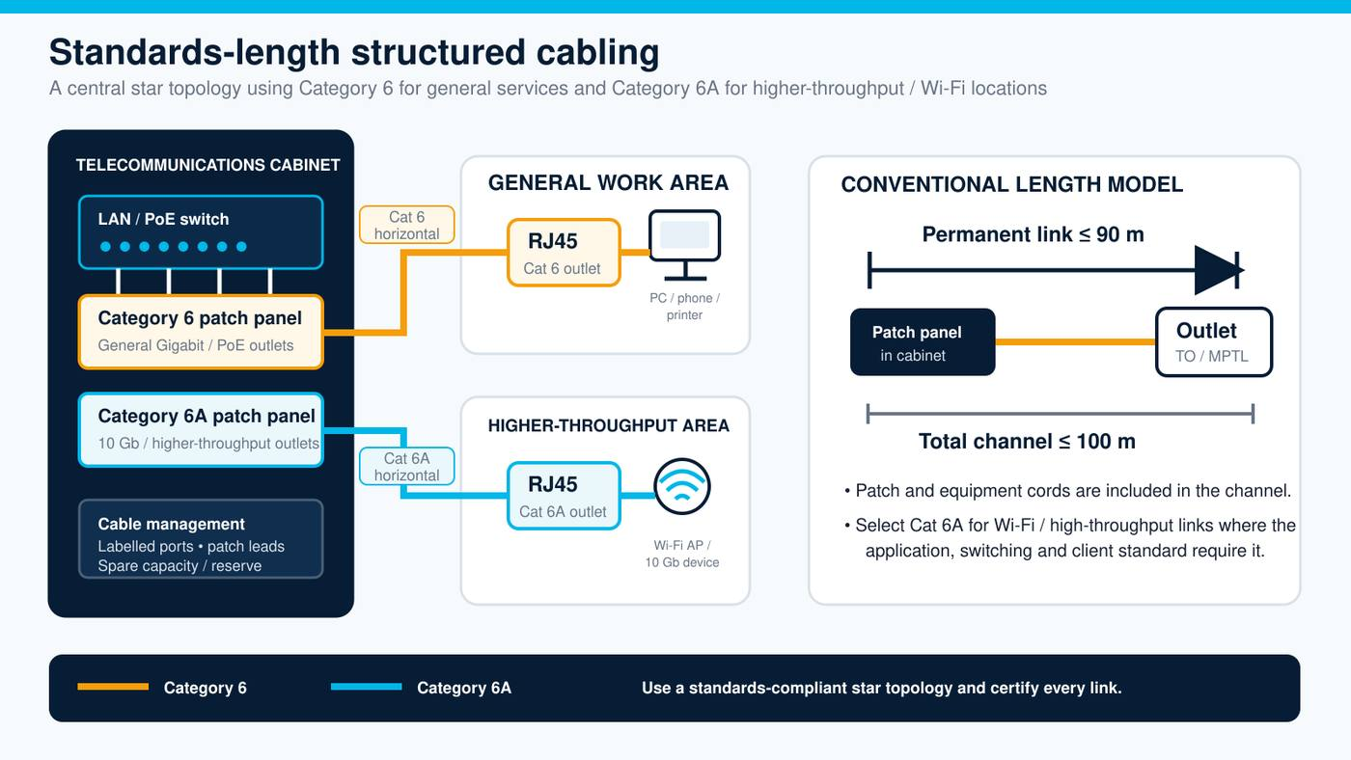
Figure 1 - Standards-length Category 6 / Category 6A structured cabling architecture.
Design intent: Category 6 is the baseline for general Gigabit and PoE outlets; Category 6A is selected where the required wired service, Wi-Fi generation, client lifecycle or 10 Gb/s application justifies it. Both remain within the adopted conventional permanent-link and channel lengths.
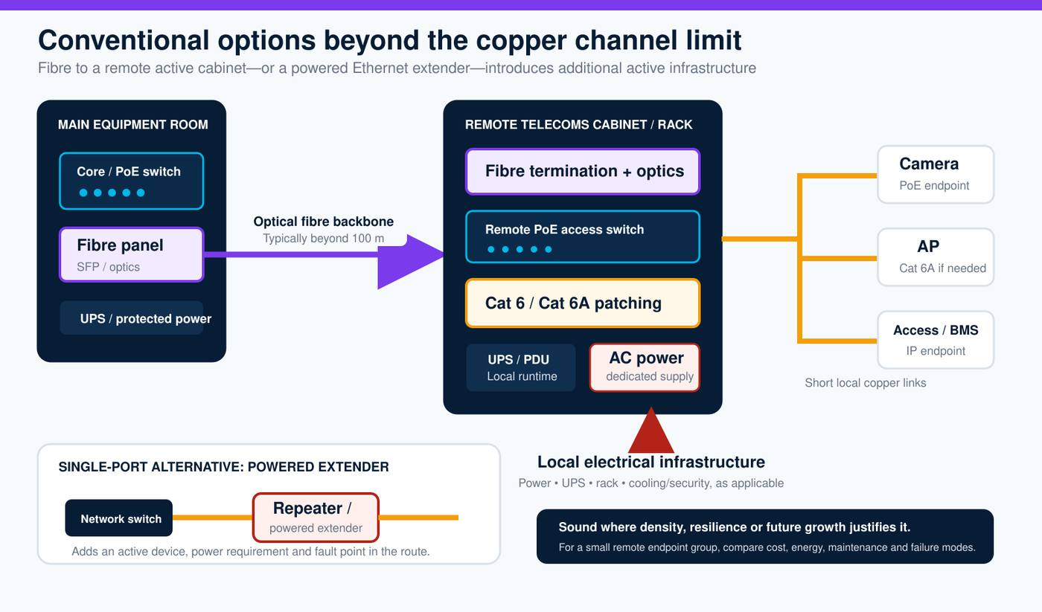
Figure 2 - Conventional beyond-limit options: fibre-fed remote cabinet or powered Ethernet extender.
Design intent: fibre and a maintained remote switch remain appropriate where endpoint density, aggregate capacity, electrical isolation, resilience or growth justifies a distribution node. For only a few eligible remote endpoints, the added rack, switch, UPS, local power and maintenance burden shall be justified rather than assumed. An inline powered extender is active equipment and requires an accessible, powered and monitored design.
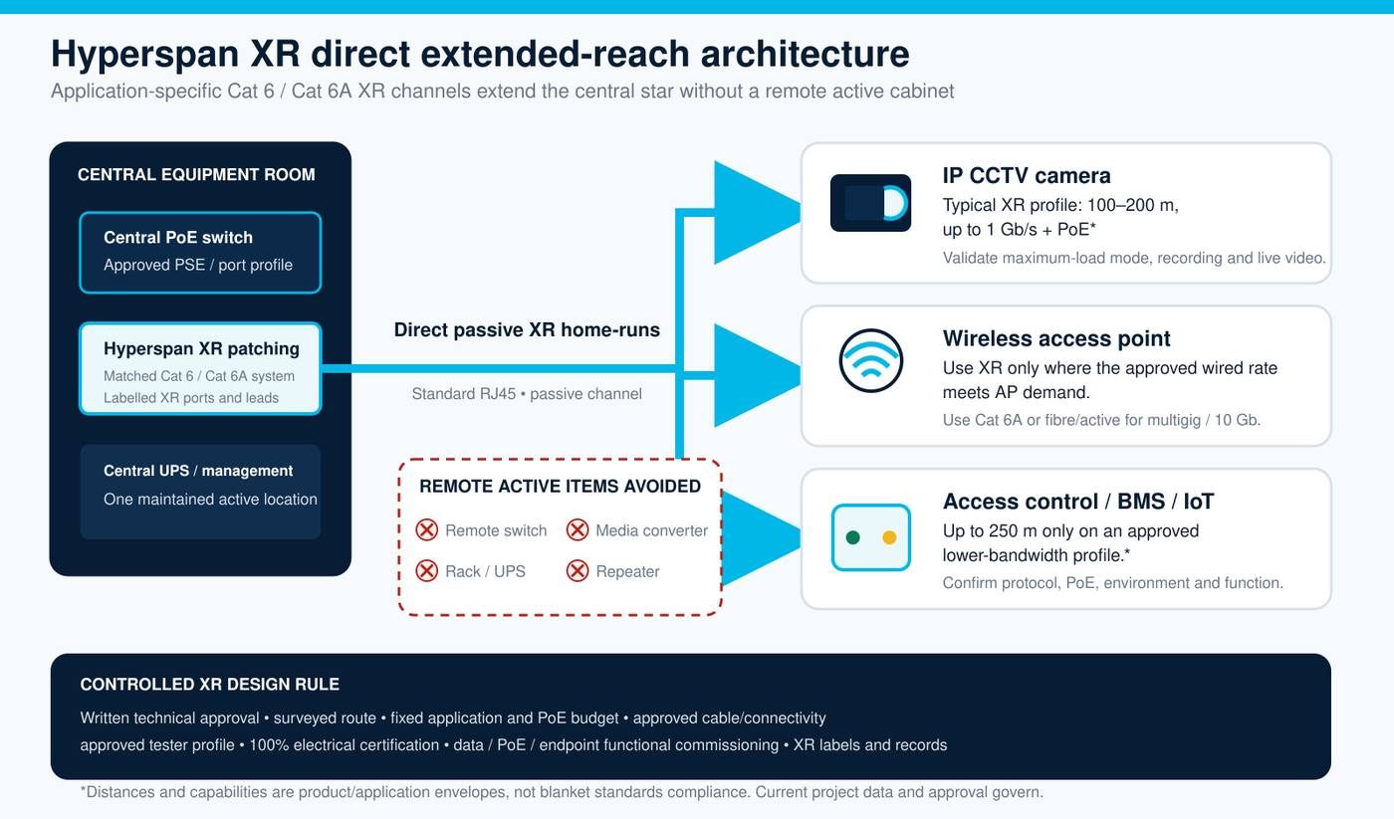
Figure 3 - Hyperspan XR direct extended-reach copper architecture.
Design intent: XR is the preferred architecture for a suitable small remote endpoint group where it removes disproportionate active infrastructure while retaining a central star. Each XR channel remains application-specific and is accepted only against its approved data-rate, PoE, length, topology, test profile and contract requirements.
Attribute | Cat 6 / Cat 6A conventional | Fibre + remote active cabinet | Hyperspan XR
Reach model | ≤90 m permanent link / ≤100 m channel | Fibre reach per optics; short local copper | Approved XR envelope: typically up to 200 m for 1 Gb/s + PoE; up to 250 m only for approved lower-bandwidth uses
Remote active equipment | None where the endpoint is within the serving area | Remote optics, switch and cabinet | None in the passive XR channel
Local power / UPS | Not required for the cabling channel | Required for the remote active node | Not required along the channel; PoE is sourced centrally
Best fit | General outlets and Cat 6A high-throughput / Wi-Fi links within limits | Endpoint density, growth, aggregate capacity, isolation or resilient distribution | Eligible remote endpoints, normally in small groups, where a new active node is disproportionate
Acceptance basis | Adopted Cat 6 or Cat 6A permanent-link / channel limit | Fibre loss/polarity plus active and local copper tests | Approved XR profile plus data, PoE-under-load and endpoint functional commissioning

5. Copper category and media selection

5.1 Selection principle
The cable category shall be selected by application and environment, not simply by choosing the highest category. The full channel - cable, panels, jacks, plugs and cords - shall be matched to the required performance and warranty scheme.
Design situation | Preferred media | Key rule
General office/data, 1 Gb/s, conventional distance | Category 6 | Use for cost-effective standards-length Gigabit access where 10 Gb/s is not a requirement.
10GBASE-T, high-density Wi-Fi, high-performance workstation or future 10 Gb/s | Category 6A | Design as a complete Cat 6A channel within conventional length limits.
High PoE density or large cable bundles | Category 6A normally preferred | Perform remote-power thermal and current-capacity assessment; cable construction and conductor size matter.
High electromagnetic disturbance | Appropriate shielded Cat 6A or fibre | Use only with a complete bonding/earthing design and compatible shielded connectivity.
More than 90 m fixed / 100 m channel, within approved XR envelope | Hyperspan XR normally preferred | Apply Section 7. If another method is selected, record the technical and whole-life justification.
Beyond approved XR envelope, 10 Gb/s long reach, interbuilding isolation or high endpoint concentration | Optical fibre / active architecture | Select fibre type, active equipment and resilience to the project application.

5.2 Category 6 requirements
- Four-pair, 100-ohm balanced solid bare-copper cable meeting the project-adopted Category 6 requirements.
- Suitable construction, jacket and declared fire performance for every part of the route.
- Category 6 panels, jacks and factory-terminated cords; a mixed-category channel is rated to its lowest-performing component.
- Intended primarily for Gigabit Ethernet and applicable PoE services within conventional topology limits.
- Copper-clad aluminium is not acceptable by default and requires explicit permission from the governing standard and client.

5.3 Category 6A requirements
- Complete Category 6A channel for the required 10GBASE-T and multigigabit applications within conventional limits.
- Alien-crosstalk performance and installation practices appropriate to the adopted standard and cable construction.
- Use Category 6A for high-density/high-throughput wireless access points, data-centre access/support networks and defined 10 Gb/s lifecycle requirements.
- Use shielded variants only where the electromagnetic and bonding design justifies them; maintain continuous, consistent bonding.
- Bend radius, bundle size, fill ratio and heat-rise implications shall be included in pathway and PoE calculations.

6. Conventional horizontal copper

6.1 Length and channel configuration
CONVENTIONAL DESIGN LIMIT
Design conventional horizontal cabling to a maximum 90 m permanent link and 100 m total channel, including patch and equipment cords, unless the adopted standard defines a shorter application-specific limit. Do not use field-tester measurement tolerance as design allowance.

- Route measurements shall follow the installed pathway rather than drawing scale or straight-line distance.
- Service loops, consolidation points and additional connectors shall be included in the design and channel model.
- Patch-cord lengths shall be controlled and documented; long or small-gauge cords can reduce the permitted fixed-cable length.
- All fixed links shall terminate in their final patch panel and outlet before permanent-link certification.

6.2 Outlet and termination architecture
- T568B shall be used throughout unless the client standard requires T568A; a project shall not mix schemes.
- Work-area outlets shall be modular, labelled and mechanically protected. Direct plug termination may be used only as an approved MPTL design for a fixed device.
- Patch panels shall provide sufficient spare capacity, front/rear management, readable labels and safe access to terminations.
- Pair twist shall be preserved to the point of termination; conductor damage, excessive untwist and repeated retermination are not acceptable.
- Components shall be installed using the correct manufacturer tooling and instructions.

7. Hyperspan XR extended-reach governance

7.1 Technical classification
Hyperspan XR is a manufacturer-engineered extended-reach copper system using standard RJ45 connectivity. The current Hyperspan product catalogue states support up to 1 Gb/s and up to 90 W PoE at 200 m, subject to system design and validation, with extension to 250 m for approved lower-bandwidth applications. The exact product data sheet and application/test profile current at the project date shall govern.
DO NOT MISCLASSIFY XR
An XR channel longer than the generic-cabling limit shall be identified as 'Hyperspan XR - [approved application profile]' in drawings, schedules, labels and reports. Passing the XR profile does not convert it into a conventional standards-length Category 6/6A link, and failure against a conventional length limit is not the correct acceptance method for an approved XR channel.

7.2 When XR shall be selected or considered
DESIGN PRESUMPTION
Where the route exceeds the conventional 90 m permanent-link or 100 m channel envelope, XR shall be the first passive-copper option assessed. For an eligible small remote endpoint group, it should be selected unless a documented technical and whole-life appraisal supports fibre or an active distribution node.

- The surveyed permanent-link route exceeds 90 m or the expected total channel exceeds 100 m.
- The endpoint application is within the current approved XR data-rate, PoE, length, connector and environmental envelope.
- Avoiding an intermediate active device, remote cabinet or new TR improves cost, programme, energy use, material demand, maintainability or resilience for the actual design.
- The endpoint count and growth forecast do not justify a higher-capacity fibre-fed distribution node.
- The link can remain a dedicated point-to-point channel with controlled components and complete records.
- The organisation or project technical authority accepts the application-specific testing and commissioning method.

7.3 Default XR application envelope
Parameter | Default model requirement
200 m design | Up to 1 Gb/s and up to 90 W PoE only where the selected product, PSE, PD, channel and load validation support it.
200-250 m design | Only for the lower-bandwidth application and power envelope explicitly approved by Hyperspan and the project technical authority.
Topology | One dedicated point-to-point passive channel. Connector count and cord lengths shall match the approved design.
Cable construction | Project-selected Hyperspan XR Cat 6 or Cat 6A construction; 22 AWG options and F/UTP with X-filler are listed in the current catalogue.
Environment | Internal LSZH or external PE/other approved construction with the required CPR/fire declaration, UV/wet protection and mechanical protection.
Connectivity | Approved Hyperspan XR-compatible patch leads, connectors, jacks/panels or project-approved system combination.
Certification | Current approved Hyperspan application-specific test limit on a compatible field tester, plus functional application and PoE-under-load validation.
Approval | Completed Appendix C and written organisational or project technical approval before installation.

7.4 Cases requiring fibre, active distribution or specific engineering review
- Required data rate exceeds the approved XR application profile, including 10 Gb/s where not explicitly supported at the proposed distance.
- Route exceeds the approved XR maximum or the link budget cannot be demonstrated.
- Large endpoint concentration, aggregate bandwidth, redundancy or growth supports a remote fibre-fed switch or new TR.
- Interbuilding route presents lightning, earth-potential, surge or electrical-isolation risk better addressed by fibre.
- The endpoint is safety-critical or authority-controlled and written acceptance has not been obtained.
- Hazardous, high-EMI, high-temperature, wet, corrosive or mechanically exposed environment without a suitable approved construction and protection design.
- Multiple undocumented couplers, repair joints, passive splitters or third-party extenders would be required.

7.5 XR design deliverables
- XR schedule with link ID, route, surveyed length, cable product code, channel components, connector count and cord lengths.
- Endpoint schedule with device model, required data rate, PSE port/type/class, PD power demand and environmental conditions.
- PoE voltage-drop/current/thermal assessment and confirmation of operation at the PD under worst-case load.
- Marked-up plan and schematic showing switch, patching, route, outlet/device and surge/bonding provisions.
- Test plan naming the test instrument, adapter, profile and version; sample report and functional commissioning method.
- Whole-life option appraisal identifying active equipment, power, space, material, maintenance, resilience and growth implications.
- Written technical approval and any conditions or limitations.

8. Application-specific design guidance
Application | Conventional design | XR design rule
IP CCTV | Cat 6 normally sufficient within conventional length where device bandwidth and PoE are met. | Strong XR candidate beyond 90/100 m. Validate camera model, codec/bitrate, PoE, night-mode/IR load, outdoor protection and live video under load.
Wireless access points | Cat 6A preferred for multigigabit/high-density Wi-Fi and high PoE. | Use XR only where the AP's required wired rate is within the approved profile. Do not constrain a multigigabit AP to 1 Gb/s without client acceptance.
Access control / intercom | Cat 6 conventional link for controllers/readers and IP intercoms. | XR candidate for remote gates, perimeter points and low-bandwidth devices; confirm lock/reader/controller power architecture and authority rules.
BMS / IoT / sensors | Cat 6 where Ethernet endpoint is within conventional distance. | XR may suit approved lower-bandwidth services up to the supported envelope; record protocol, power and latency requirements.
Small remote group, normally 1-10 outlets | Conventional copper if a suitable serving TR is already within limits. | XR is the preferred beyond-limit design where the application, port, pathway and growth analysis supports individual home-runs; document any alternative.
Data-centre support | Cat 6A for 10 Gb/s access; fibre for high-speed fabric/backbone. | XR limited to approved support uses such as CCTV, sensors, plant or out-of-band 1 Gb/s links; not the default for server/storage fabric.
Outdoor / campus | External-rated copper only where electrical and surge risks are acceptable; fibre otherwise. | Use external XR construction, entry protection, surge/bonding assessment, water management and mechanical protection. Fibre remains preferred for electrical isolation.
Temporary / deployable | Use rugged deployable cabling designed for repeated handling. | Use approved Hyperspan XR deployable reel assembly, inspect before/after use and follow project rules for connector/environmental protection.

8.1 Representative pilot and first-article acceptance
Where an organisation has no established XR acceptance route, the project should construct a representative pilot or first-article link using the proposed switch/PSE, full proposed cable length, connector topology and intended endpoint. The pilot record shall include:
- Field-certification report using the approved Hyperspan XR test limit.
- Negotiated link speed and error/packet-loss or throughput evidence appropriate to the system.
- Endpoint service verification under its specified operating modes: for example CCTV resolution/frame rate/night load, Wi-Fi traffic service, or control/BMS command and telemetry.
- PoE class, PSE output and PD operation under worst-case load; voltage/power measurements where required by the approval plan.
- A soak period defined by the technical authority. The default model value is at least 60 minutes; critical trials may require a longer witnessed period.
- Signed witness record, device firmware/version and any conditions attached to acceptance.

9. Telecommunications spaces, pathways and resilience

9.1 Equipment rooms and cabinets
- TRs, ERs and cabinets shall provide secure access, maintainable working clearances, ventilation/cooling, power, earthing/bonding and environmental monitoring appropriate to the active equipment.
- Rooms shall be clean, dry and weather-tight, with no unrelated water or drainage services routed above ICT equipment; finishes and floor treatment shall suit the environment and maintenance regime.
- Coordinate lighting, fire detection/suppression, access control, electrical distribution and separate ICT/power/fibre containment before equipment installation.
- Rack capacity shall include panels, switches, cable management, UPS/power distribution and a project-defined spare allowance.
- Submit cabinet elevations showing patch panels, horizontal and vertical management, switches, fibre, UPS/PDU, spare rack units and bonding before manufacture or installation.
- An active device shall not be placed above a ceiling, outdoors or in an inaccessible enclosure merely to overcome cable distance.
- Where XR avoids a remote active cabinet, the design record shall identify the eliminated active infrastructure and confirm that central switch-port capacity remains available.

9.2 Pathways and containment
- Pathways shall be continuous, accessible, sized for the installed cable diameter, bend radius, PoE bundle limits and planned growth.
- Cable tray, basket, conduit and supports shall prevent crushing, sharp edges, excessive sag and exposure to maintenance damage.
- Telecommunications cable shall not be supported from ceiling grid, pipework, ducts or other services.
- Power/data segregation, crossings and barriers shall meet the adopted installation standard, electrical rules and EMC assessment.
- Penetrations shall be sleeved where required and fire-stopped using a tested, compatible and maintainable system.
- External ducts shall be drained/sealed as designed and shall not be assumed dry. Cable shall be rated for the actual route.

9.3 Resilience and single points of failure
Reducing active devices can remove power, UPS, cooling and switch failure points, but long home-runs can also concentrate service at one central switch or pathway. The design shall therefore consider:
- Switch chassis/stack resilience and spare PoE budget.
- Diverse pathways for critical cameras or control devices where required.
- Local isolation and repair time for a damaged long link.
- Surge/lightning exposure and electrical separation.
- Monitoring of port state, power consumption and endpoint availability.
- Operational spares for the installed cable/connectivity and access to the current test profile.

9.4 Whole-life cost and sustainability record
The design record shall explain how the selected architecture affects whole-life cost and environmental performance. XR benefits shall be claimed only where the comparison reflects the project quantities, duty cycle and maintenance model.
- Record active items avoided or introduced, including switches, optics, extenders, racks, cabinets, UPS/PDU, batteries, local power supplies and cooling.
- Compare operational energy and planned replacement over the client's assessment period, including remote equipment that would otherwise run continuously.
- Compare containment, equipment space, electrical work, fire-stopping, access, commissioning and future maintenance visits.
- Record material quantities or embodied-carbon evidence where the project requires carbon reporting; do not rely on unsupported blanket percentage claims.
- Balance these benefits against capacity, redundancy, isolation, growth and repair considerations so that sustainability does not compromise the service requirement.

10. Installation workmanship

10.1 Pre-installation
- Approve product submittals, design schedules, route drawings, fire classifications, installer qualifications and test method before work starts.
- Survey all routes and verify length; do not rely solely on tender drawings.
- Inspect cable packaging, batch identification and declarations on receipt; store dry, secure and within manufacturer environmental limits.
- Confirm the correct cable is allocated to internal, external, wet, UV, fire-rated, armoured or deployable sections.
- For XR, confirm the link ID, exact product, length envelope, components and approved test profile before cutting cable.

10.2 Cable placement
- Observe manufacturer maximum pulling tension and minimum bend radius during and after installation.
- Do not kink, crush, knot, staple, over-tighten or deform the cable. Hook-and-loop ties are preferred in maintained bundles.
- Use cable supports at intervals that prevent damaging sag; maintain pathway fill and access.
- Protect cable ends from moisture and contamination. Replace, rather than conceal, damaged sections unless an approved repair method exists.
- Maintain separation from heat sources, luminaires, motors, transformers and power cabling in accordance with the adopted standard and EMC assessment.
- Provide controlled service loops without tight coils or congestion. Service-loop length is part of the channel length.

10.3 Termination and patching
- Use only the approved connector and tool for the cable construction and conductor size.
- Preserve pair geometry and foil/drain continuity as applicable; terminate shields using a complete 360-degree or manufacturer-approved method.
- No more than the approved number of connection points shall be introduced into an XR channel.
- Patch and equipment cords shall be factory terminated, correctly rated and kept to the scheduled lengths.
- Ports shall be dressed without obstructing airflow, labels or adjacent equipment and without placing load on connector latches.

10.4 Outdoor and building-entry work
- External PE or other non-building-rated cable shall transition at the permitted building-entry point unless its declaration permits the internal route.
- Provide surge protection, bonding, shielding and equipment protection based on a documented risk assessment and local electrical requirements.
- Use weatherproof/IP-rated housings and glands appropriate to the connector and device; prevent water tracking along cable.
- Provide UV, rodent, impact, burial-depth and mechanical protection appropriate to the site.
- Do not use metallic copper between buildings where the electrical risk requires optical isolation.

11. Power over Ethernet and thermal design

11.1 Required calculations and records
Every PoE link shall be designed as a power-and-data system. For XR, the extended length makes resistance, voltage drop and powered-device behaviour especially important. The designer shall record:
- PSE manufacturer/model, port type/class, power budget and configuration.
- PD manufacturer/model, required class, maximum input power and minimum operating voltage.
- Cable product, conductor size/material, length, connector count and patch-cord construction.
- Ambient temperature, pathway environment, bundle size, fill, ventilation and applicable derating.
- Worst-case voltage drop, loop resistance and available power at the PD.
- Commissioning measurement or functional evidence under maximum expected device load.

11.2 PoE design rules
- Do not approve a link solely because the PSE reports a negotiated PoE class; confirm the PD remains stable under its maximum operating condition.
- For cameras, test the night/IR heater, wiper, illuminator or other maximum-load mode where fitted.
- For wireless access points, test peak radio operation or the manufacturer's maximum-load commissioning method where available.
- Avoid unnecessarily large bundles of continuously powered cables; distribute high-power loads and respect cable/pathway thermal limits.
- Any change to PSE, PD, link length, patch cords or connector count shall trigger review of the original PoE basis.

12. Field testing and commissioning

12.1 General
- Test 100% of installed copper links after final termination and before service handover.
- Use a calibrated field tester and adapters appropriate to the permanent-link or channel configuration and the selected test limit.
- Record tester make/model, serial numbers, adapter type, software/limits version, calibration dates, operator, date, cable ID and result.
- PASS is required. FAIL, warning-only acceptance, manually edited result files or unidentified limits are not acceptable unless the client approves a documented concession.
- Correct faults and retest the complete link; do not submit only the later pass without retaining the quality record required by the project.

12.2 Conventional Category 6 / 6A
Conventional links shall be certified using the adopted current Category 6 or Category 6A permanent-link limit, as applicable. At minimum the certification shall evaluate wire map, length, propagation delay/skew, insertion loss, return loss, NEXT/PSNEXT and applicable ACR parameters. Resistance and resistance-unbalance results shall be included where remote powering is designed or required by the project.

12.3 Hyperspan XR certification
XR links shall use the current project-approved Hyperspan test-limit profile on a compatible field tester. The current Hyperspan resource set includes a 'Hyperspan 200 m / 1 Gb Channel' test limit for compatible Fluke Networks Versiv/DSX CableAnalyzers. This enables XR field certification on the familiar Fluke platform; it does not classify the channel as a conventional standards-length Category 6 link or imply a separate Fluke product endorsement.
CONTRACT TESTING REQUIREMENT
The contract shall name the approved tester family, adapters, Hyperspan profile and controlled version, calibration requirement, report format, pass criteria, sampling/witness level and functional/PoE tests. The installer shall use that exact profile and shall not substitute a conventional Category 6 length limit or an unnamed custom limit.

XR acceptance layer | Evidence required
Physical/channel certification | PASS report against the approved Hyperspan XR profile, with cable ID, measured length, tester/profile version and full result detail.
Data application | Correct negotiated rate and a project-defined functional or traffic test demonstrating stable operation.
PoE application | Correct PSE/PD negotiation and stable powered-device operation at maximum expected load; measurements where required by the approval plan.
System function | For CCTV, live and recorded video; for WAP, network service; for control/BMS, command, alarm and telemetry functions.
Contract record | Native Fluke project/result files and human-readable reports in the contract format, retained with the approved profile/version.
Witness / approval | Signed record where required by the client or approving authority, including deviations and conditions of use.

12.4 Hyperspan profile test workflow and warranty evidence
The following workflow shall be written into the project Inspection and Test Plan where XR is used. It supplements—rather than replaces—the tester manufacturer's instructions, the controlled Hyperspan profile guide, the approved project topology and the current Hyperspan warranty terms.
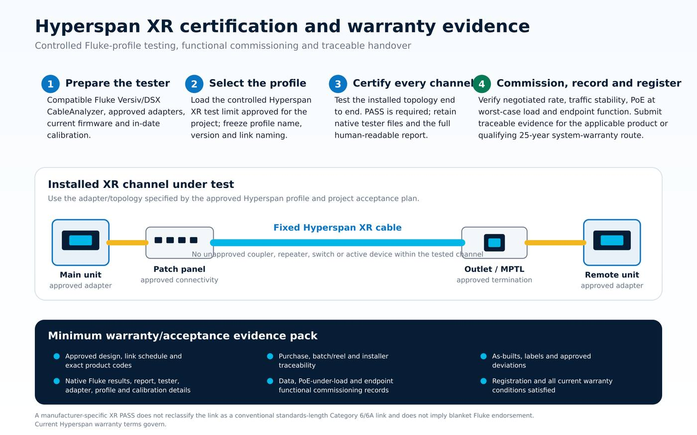
Figure 4 - Hyperspan XR certification, functional commissioning and warranty-evidence workflow.
- Before testing. Verify compatible Fluke Versiv/DSX CableAnalyzer model, approved channel/permanent-link adapters as applicable, current supported firmware, in-date calibration, controlled Hyperspan profile name/version and the project naming structure.
- During certification. Test every completed XR channel in its approved topology, retain all measured parameters and accept only a valid PASS against the frozen profile. A conventional Category 6 or Category 6A 90 m/100 m limit shall not be substituted for the XR profile.
- After electrical PASS. Confirm negotiated data rate, stable traffic, PoE operation at the worst expected device load and the required endpoint function. An electrical PASS alone does not accept an application that is unstable or under-powered.
- Warranty submission. Retain product codes, purchase and batch/reel traceability, installer details, as-built routes, native tester files, PDF reports, tester/adapter/profile/calibration details, functional results, approved deviations and registration evidence.
25-YEAR WARRANTY ROUTE
The catalogue publishes a 25-year system warranty. A 25-year limited product warranty and a 25-year system warranty are different contractual routes: the system route applies only to a qualifying registered complete system and remains subject to current written Hyperspan terms, eligible components, approved design and installation conditions, complete test evidence and timely registration. Obtain written confirmation of the required route before procurement.

12.5 Commissioning failures
If a link passes its electrical profile but fails the application test, it is not accepted. Investigate PSE configuration, patch cords, connectors, cable damage, endpoint firmware, autonegotiation, PoE load, temperature and test-profile selection. Any remedial change shall be documented and the complete acceptance sequence repeated.

13. Identification, administration and records

13.1 Identification convention
The client shall adopt one unique identifier for every link, matching drawings, patch panel, outlet/device label, test result and asset register. The media/application type shall be visible in the electronic register and, for XR, on the physical labels.
Type | Example identifier | Required description
Cat 6 | B01-TR1-PP01-024 | Category 6 conventional permanent link
Cat 6A | B01-TR1-PP02-012 | Category 6A conventional permanent link
XR 200 m / 1 Gb | B01-TR1-XR01-006 | HYPERSPAN XR - 200 m / 1 Gb profile - [device/service]
XR approved lower bandwidth | B01-TR1-XR02-003 | HYPERSPAN XR - [approved profile] - [device/service]

13.2 XR warning/maintenance label
RECOMMENDED LABEL TEXT
HYPERSPAN XR EXTENDED-REACH CHANNEL - DO NOT CERTIFY TO A CONVENTIONAL 90 m / 100 m LENGTH LIMIT. REFER TO LINK REGISTER AND APPROVED XR TEST PROFILE BEFORE ALTERATION.

13.3 Required records
- As-built floor plans, risers, schematics, rack elevations and pathway routes.
- Copper link schedule with source/destination, media, product, route length, connector count and service.
- Native tester project files and human-readable PDF reports.
- XR approval records, PoE calculations, pilot/witness reports and applicable test-profile files/guides.
- Product data sheets, CPR/declarations, batch references and approved substitutions.
- Photographs of racks, labels, outlets, external entries, fire-stopping and concealed work where required.
- Warranty registration, installer certification and operation/maintenance guidance.

14. Quality assurance, handover and warranty

14.1 Quality controls
- Installer competence shall be demonstrated for the selected cabling system, tester and specialist environments.
- The project quality plan shall identify hold points for submittals, first-off termination, concealed pathways, fire-stopping, pilot testing and final records.
- Substitutions shall be approved before installation and shall not reduce channel performance, fire compliance, PoE capacity, testability or warranty eligibility.
- A sample or first-article XR link should be installed and accepted before high-volume rollout where the organisation or project is new to XR.
- Independent witness testing may be required for authority-controlled, critical or disputed installations.

14.2 Handover
Handover shall not be complete until physical works, testing, application commissioning, records, training and defects are closed. The client shall receive editable schedules and native test files, not only scanned or flattened summaries.

14.3 Warranty and contractual compliance
Product-only and system-warranty terms are distinct and shall not be conflated. The procurement documents shall state which warranty route applies to conventional and XR channels, the required term, eligible products, installer conditions, registration process and evidence required at handover.
- The 25-year limited product-warranty route applies only to the individual supplied product and only in accordance with its current written terms, limitations, exclusions and evidence requirements.
- The catalogue-published 25-year Hyperspan system-warranty route is for a qualifying registered complete system of eligible cable, panels/connectivity and cords, subject to approved design, installation, installer conditions, testing, traceability, registration and all current written warranty conditions.
- Fluke-based XR certification using the controlled Hyperspan manufacturer profile forms part of the technical and contractual evidence where specified. Profile availability depends on compatible tester hardware, adapters, firmware and the controlled file/version confirmed by Hyperspan; it is not a blanket Fluke endorsement.
- Every required native result file, PDF report, application test, PoE-under-load record and approval shall be delivered before warranty submission and contract completion.
Current manufacturer resources: Hyperspan website • Product catalogue • Technical support

15. Operations, maintenance and change control
- Moves, adds and changes shall preserve the link ID and update drawings, schedules and test records.
- Do not add couplers, longer patch cords, converters, extenders or unapproved endpoint loads to an XR channel without design review.
- Replacement PSE/PD equipment shall be checked against the original data-rate and PoE design basis.
- Damaged copper shall normally be replaced as a continuous run; repairs require an approved method and complete retest.
- Periodic inspection shall include labels, patching, bend radius, environmental seals, surge protection, bonding, external damage and tester/profile availability.
- The asset register shall flag XR links so service teams do not test or alter them as ordinary 90 m permanent links.

Appendix A - Design decision matrix
Question | If yes | If no / escalation
Is the surveyed fixed route <=90 m and total channel <=100 m? | Use conventional Cat 6 or Cat 6A selection. | Continue XR/fibre/active option appraisal.
Does the endpoint require 10 Gb/s or more than the approved XR data rate? | Use Cat 6A within limits or fibre/active architecture. | Continue XR eligibility review.
Is the proposed XR link <=200 m? | Assess 1 Gb/s and PoE application against current product profile. | For 200-250 m, only use an approved lower-bandwidth profile; beyond that use fibre/active.
Is PoE required? | Complete PSE/PD, voltage-drop, thermal and full-load validation. | Record that the link is data-only.
Is the route interbuilding/outdoor/high-risk? | Complete surge, bonding, wet/UV, mechanical and electrical-isolation review; fibre may be mandatory. | Use the correct internal construction and fire declaration.
Would XR avoid a remote switch/TR for a small endpoint group? | Use XR where eligible unless the appraisal justifies another architecture. | A fibre-fed distribution point may be better for density/growth.
Is the system authority-controlled or life-safety related? | Written authority approval and pilot/witness testing required. | Client technical approval is still required.
Has Appendix C been approved and the test profile frozen? | Proceed to controlled procurement/installation. | Do not install XR production links.

Appendix B - Hyperspan product schedule
This appendix is the specification-ready schedule for this model: Hyperspan XR extended-reach products and the matched conventional Category 6 / Category 6A copper and connectivity used with those channels. Product codes, names and published variants are reproduced from the live catalogue pages listed below and do not replace the exact product code, current data sheet, declaration, written quotation or approved material submittal. Cat 5e, Cat 7A, voice, industrial, tools and management accessories remain available from the live catalogue and are not the default specified channel here.
PRODUCT SELECTION CONTROL
Use only the exact product code approved for the project category, construction, environment, fire classification, shielding, length and warranty route. Before procurement, verify availability and obtain the current data sheet, CPR/declaration where applicable, installation instructions, compatibility statement and written warranty conditions from Hyperspan.

Current source: Hyperspan Product Catalogue • Sales enquiry • Technical support
Schedule family | Included catalogue product lines
XR extended reach | Cat 6/Cat 6A XR bulk cable; 200 m/250 m deployable reels; XR patch leads and XR connectors
Core copper | Conventional Cat 6 and Cat 6A bulk cable constructions used within the 90 m / 100 m envelope
Rack / Terminate / Connect | Loaded and unloaded panels; keystone and faceplate jacks; field plugs; Cat 5e/Cat 6/Cat 6A/Cat 7 patch leads

B.1 XR Cat 6 / Cat 6A bulk cable
XR internal and external 22 AWG F/UTP constructions. Project selection shall match the approved application profile, route environment and fire strategy.
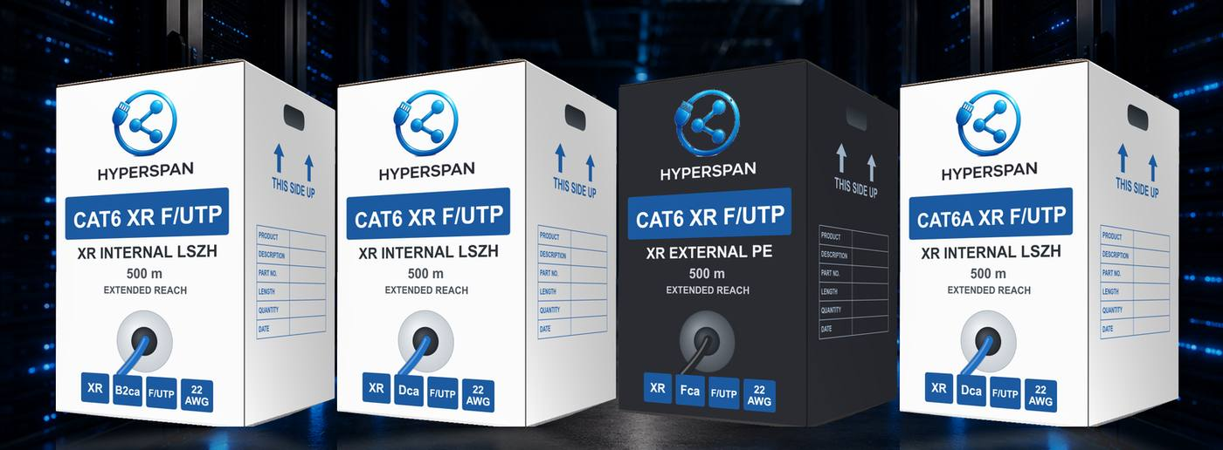
Live catalogue page 5
Product line item | Product name / description | Published variant / pack
HSP-CAT6-XR-INT-FUTP-B2CA-S1A-D0-A1-BLUE-500 | Cat6 XR Internal LSZH F/UTP with X filler — B2ca-s1a,d0,a1, 22 AWG, 500 m box. | F/UTP • B2ca • LSZH • 500 m Box
HSP-CAT6-XR-INT-FUTP-CCA-S1-D1-A1-BLUE-500 | Cat6 XR Internal LSZH F/UTP with X filler — Cca-s1,d1,a1, 22 AWG, 500 m box. | F/UTP • Cca • LSZH • 500 m Box
HSP-CAT6-XR-INT-FUTP-DCA-S1-D1-A1-BLUE-500 | Cat6 XR Internal LSZH F/UTP with X filler — Dca-s1,d1,a1, 22 AWG, 500 m box. | F/UTP • Dca • LSZH • 500 m Box
HSP-CAT6-XR-INT-FUTP-FCA-BLUE-500 | Cat6 XR Internal LSZH F/UTP with X filler — Fca, 22 AWG, 500 m box. | F/UTP • Fca • LSZH • 500 m Box
HSP-CAT6-XR-EXT-FUTP-FCA-BLACK-500 | Cat6 XR External PE F/UTP with X filler — Fca, 22 AWG, 500 m box. | F/UTP • Fca • PE • 500 m Box
HSP-CAT6A-XR-INT-FUTP-B2CA-S1A-D0-A1-BLUE-500 | Cat6A XR Internal LSZH F/UTP with X filler — B2ca-s1a,d0,a1, 22 AWG, 500 m box. | F/UTP • B2ca • LSZH • 500 m Box
HSP-CAT6A-XR-INT-FUTP-CCA-S1-D1-A1-BLUE-500 | Cat6A XR Internal LSZH F/UTP with X filler — Cca-s1,d1,a1, 22 AWG, 500 m box. | F/UTP • Cca • LSZH • 500 m Box
HSP-CAT6A-XR-INT-FUTP-DCA-S1-D1-A1-BLUE-500 | Cat6A XR Internal LSZH F/UTP with X filler — Dca-s1,d1,a1, 22 AWG, 500 m box. | F/UTP • Dca • LSZH • 500 m Box
HSP-CAT6A-XR-INT-FUTP-FCA-BLUE-500 | Cat6A XR Internal LSZH F/UTP with X filler — Fca, 22 AWG, 500 m box. | F/UTP • Fca • LSZH • 500 m Box
HSP-CAT6A-XR-EXT-FUTP-FCA-BLACK-500 | Cat6A XR External PE F/UTP with X filler — Fca, 22 AWG, 500 m box. | F/UTP • Fca • PE • 500 m Box

B.2 XR deployable reels
Factory-prepared external Cat 6 XR reel formats for temporary or deployable applications; confirm the approved endpoint, data and power envelope.
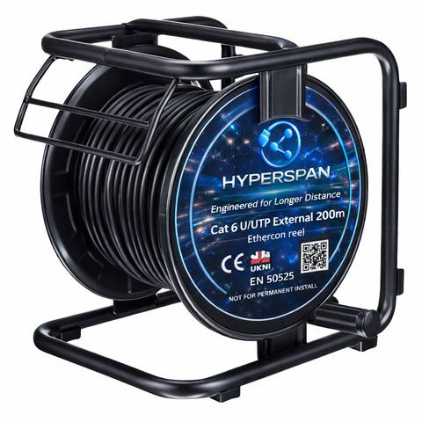
Live catalogue page 6
Product line item | Product name / description | Published variant / pack
HSP-XR-EXT-FCA-200R | Cat6 XR External – 200 m Reel — part of XR Extended-Reach Deployable Reels. | F/UTP • PE • Deployable Reel
HSP-XR-EXT-FCA-250R | Cat6 XR External – 250 m Reel — part of XR Extended-Reach Deployable Reels. | F/UTP • PE • Deployable Reel

B.3 XR patch leads
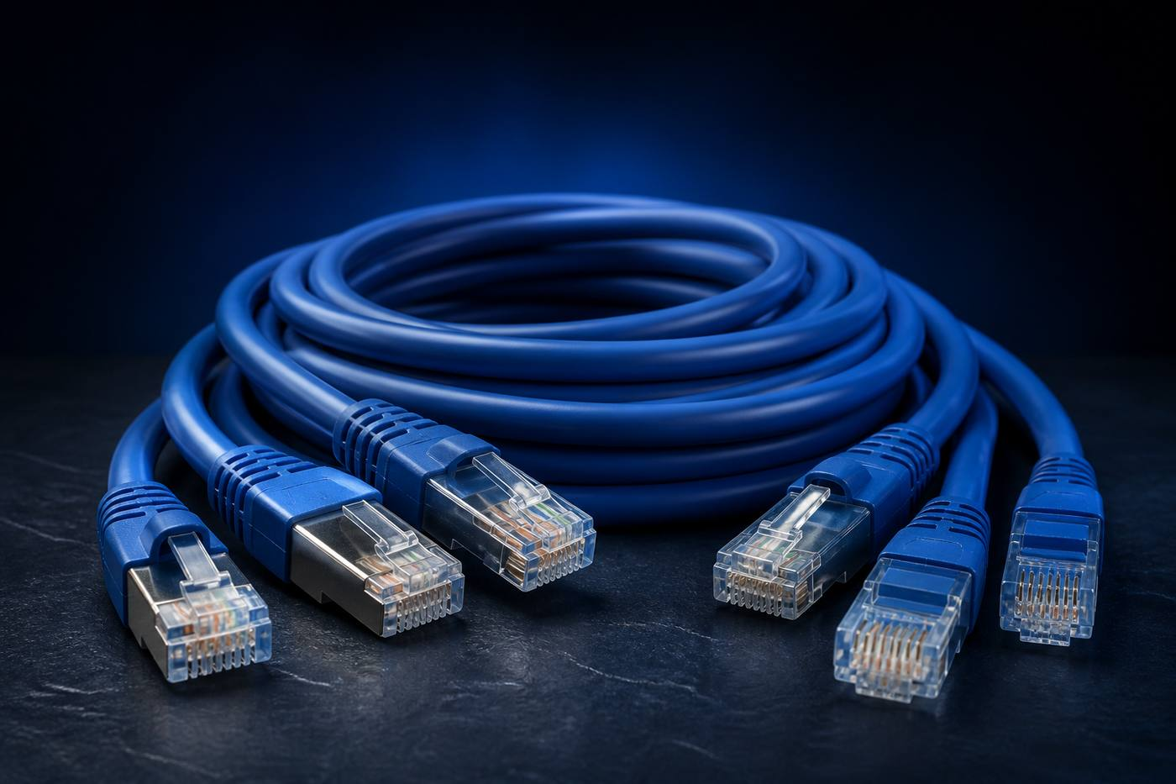
Live catalogue page 7
Product line item | Product name / description | Published variant / pack
HSP-XR-PL-1M | Hyperspan XR™ Category 6 Extended-Reach Patch Lead 1m | 1m • Blue • 1
HSP-XR-PL-2M | Hyperspan XR™ Category 6 Extended-Reach Patch Lead 2m | 2m • Blue • 1
HSP-XR-PL-3M | Hyperspan XR™ Category 6 Extended-Reach Patch Lead 3m | 3m • Blue • 1
HSP-XR-PL-5M | Hyperspan XR™ Category 6 Extended-Reach Patch Lead 5m | 5m • Blue • 1
HSP-XR-PL-10M | Hyperspan XR™ Category 6 Extended-Reach Patch Lead 10m | 10m • Blue • 1

B.4 XR connectors
Live catalogue page 7
Product line item | Product name / description | Published variant / pack
HSP-XR-RJ45-STD | Hyperspan™ XR Standard RJ45 Connector | Standard • Clear • 100
HSP-XR-RJ45-PT | Hyperspan™ XR Pass-Through RJ45 Connector | Pass-Through • Clear • 100
HSP-XR-RJ45-TL | Hyperspan™ XR Toolless Connector | Toolless • Silver • 1

B.5 Core Category 6 bulk cable
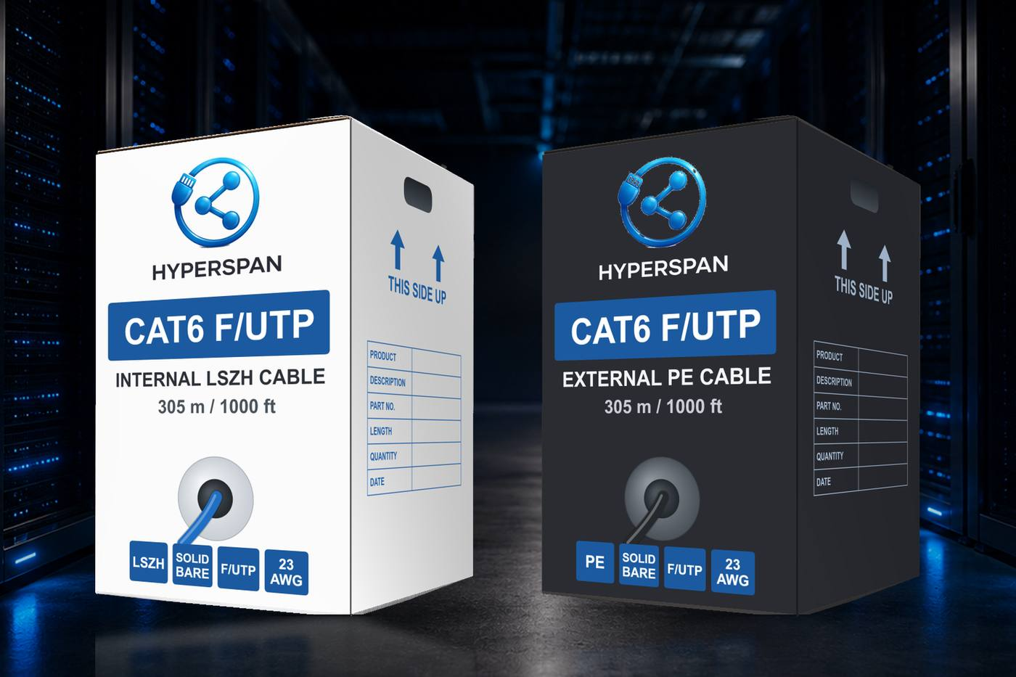
Live catalogue page 12
Product line item | Product name / description | Published variant / pack
HSP-C6-INT-B2-305 | Cat6 Internal F/UTP B2ca | F/UTP • LSZH • B2ca • 305 m Box
HSP-C6-INT-D-305 | Cat6 Internal F/UTP | F/UTP • LSZH • Dca • 305 m Box
HSP-C6-EXT-F-305 | Cat6 External F/UTP | F/UTP • PE • Fca • 305 m Box
HSP-C6-INTEXT-D-305 | Cat6 Internal / External F/UTP | F/UTP • Hybrid • Dca • 305 m Box
HSP-C6-SWA-305 | Cat6 SWA Armoured F/UTP | F/UTP • PE/SWA • Fca • 305 m Drum

B.6 Core Category 6A bulk cable
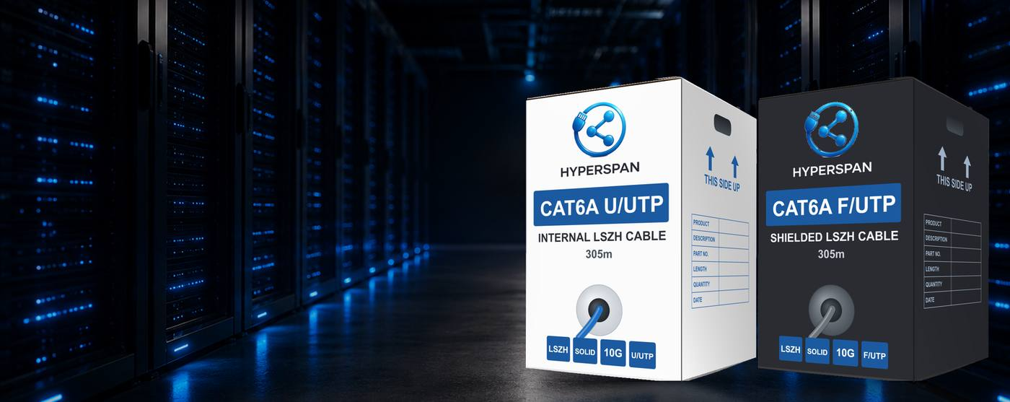
Live catalogue page 14
Product line item | Product name / description | Published variant / pack
HSP-C6A-INT-B2-305 | Cat6A Internal U/UTP | U/UTP • LSZH • B2ca • 305 m Box
HSP-C6A-INT-D-305 | Cat6A Internal U/UTP | U/UTP • LSZH • Dca • 305 m Box
HSP-C6A-EXT-F-305 | Cat6A External U/UTP | U/UTP • PE • Fca • 305 m Box
HSP-C6A-SHLD-D-305 | Cat6A Shielded F/UTP | F/UTP • LSZH • Dca • 305 m Box

B.7 Rack loaded patch panels
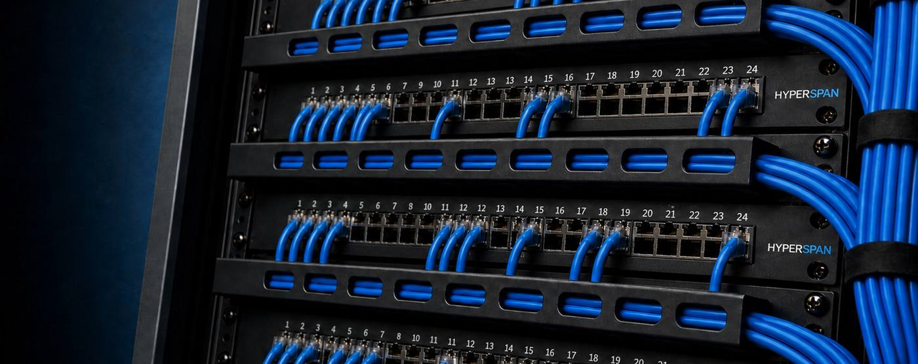
Live catalogue page 19
Product line item | Product name / description | Published variant / pack
HSP-RACK-C6-24-L | Cat6 Loaded Patch Panel | Cat6 • Loaded • 24 • 1U
HSP-RACK-C6-48-L | Cat6 Loaded Patch Panel | Cat6 • Loaded • 48 • 2U
HSP-RACK-C6A-24-L | Cat6A Loaded Patch Panel | Cat6A • Loaded • 24 • 1U
HSP-RACK-C6A-48-L | Cat6A Loaded Patch Panel | Cat6A • Loaded • 48 • 2U
HSP-RACK-SH-C6-24-L | Shielded Cat6 Loaded Patch Panel | Cat6 • Shielded Loaded • 24 • 1U
HSP-RACK-SH-C6A-24-L | Shielded Cat6A Loaded Patch Panel | Cat6A • Shielded Loaded • 24 • 1U

B.8 Rack unloaded patch panels
Live catalogue page 20
Product line item | Product name / description | Published variant / pack
HSP-RACK-UKP-24 | Unloaded Keystone Patch Panel | Cat5e–Cat7A • Unloaded • 24 • 1U
HSP-RACK-UKP-48 | Unloaded Keystone Patch Panel | Cat5e–Cat7A • Unloaded • 48 • 2U
HSP-RACK-SH-UKP-24 | Shielded Keystone Patch Panel | Cat5e–Cat7A • Unloaded Shielded • 24 • 1U
HSP-RACK-SH-UKP-48 | Shielded Keystone Patch Panel | Cat5e–Cat7A • Unloaded Shielded • 48 • 2U
HSP-RACK-HDP-24 | High-Density Keystone Patch Panel | Cat6A–Cat7A • Unloaded • 24 • 1U
HSP-RACK-HDP-48 | High-Density Keystone Patch Panel | Cat6A–Cat7A • Unloaded • 48 • 1U

B.9 Terminate keystone jacks
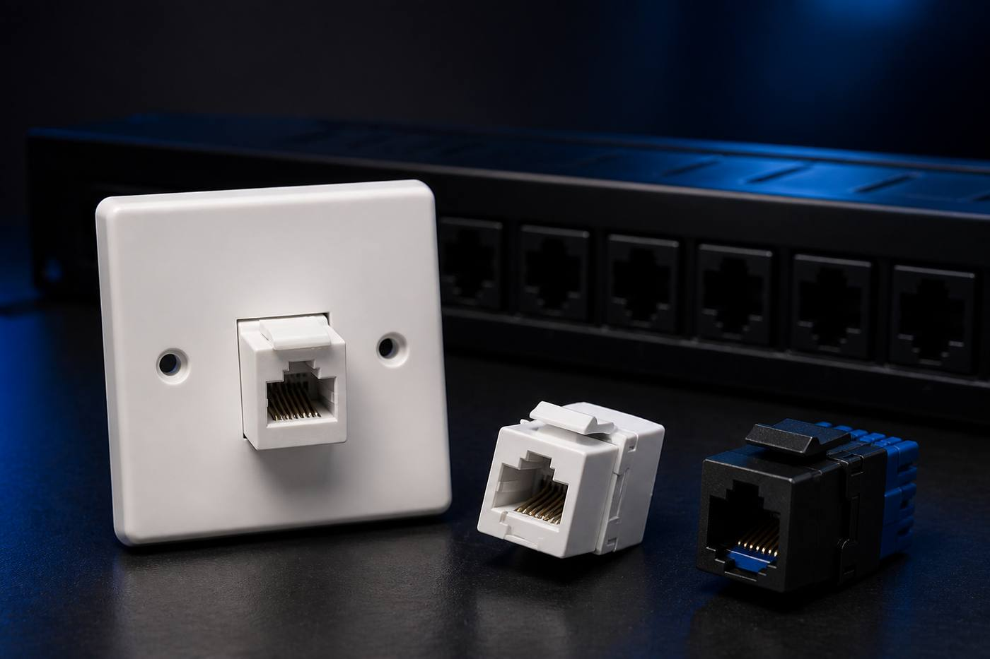
Live catalogue page 22
Product line item | Product name / description | Published variant / pack
HSP-TERM-C6-KJ | Cat6 Keystone Jack | Cat6 • Keystone • 1
HSP-TERM-C6A-KJ | Cat6A Keystone Jack | Cat6A • Keystone • 1
HSP-TERM-C6-KJ-SH | Cat6 Shielded Keystone Jack | Cat6 • Shielded Keystone • 1
HSP-TERM-C6A-KJ-SH | Cat6A Shielded Keystone Jack | Cat6A • Shielded Keystone • 1

B.10 Terminate faceplate jacks
Live catalogue page 24
Product line item | Product name / description | Published variant / pack
HSP-TERM-C6-FPJ | Cat6 Faceplate Jack — Straight | Cat6 • Straight • 1
HSP-TERM-C6-FPJ-A | Cat6 Faceplate Jack — Angled | Cat6 • Angled • 1
HSP-TERM-C6A-FPJ | Cat6A Faceplate Jack — Straight | Cat6A • Straight • 1
HSP-TERM-C6A-FPJ-A | Cat6A Faceplate Jack — Angled | Cat6A • Angled • 1
HSP-TERM-XR-FPJ | XR™ Faceplate Jack — Straight | XR • Straight • 1
HSP-TERM-XR-FPJ-A | XR™ Faceplate Jack — Angled | XR • Angled • 1

B.11 Connect field termination plugs
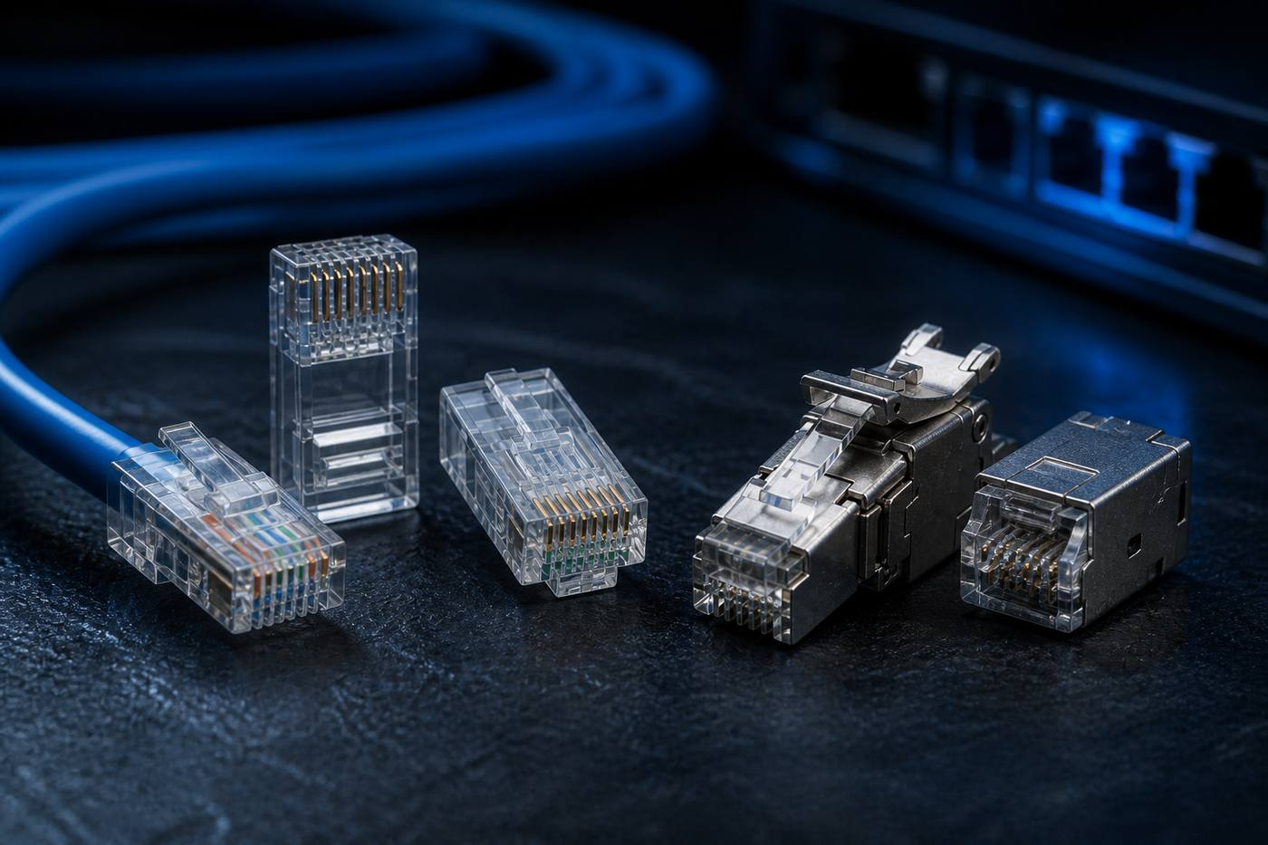
Live catalogue page 26
Product line item | Product name / description | Published variant / pack
HSP-CON-RJ45-STD | Standard Field RJ45 Connector | Standard • Cat5e–Cat6 • 100
HSP-CON-RJ45-PT | Pass-Through Field RJ45 Connector | Pass-Through • Cat5e–Cat6A • 100
HSP-CON-RJ45-TL | Toolless Field RJ45 Connector | Toolless • Cat5e–Cat6A • 1
HSP-CON-RJ45-SH | Shielded Field RJ45 Connector | Shielded • Cat6A–Cat7A • 50

B.12 Connect Category 6 patch leads

Live catalogue page 29
Product line item | Product name / description | Published variant / pack
HSP-CON-C6-025-BLU | Hyperspan™ Category 6 Patch Lead 0.25m | 0.25m • Blue • Individual
HSP-CON-C6-050-BLU | Hyperspan™ Category 6 Patch Lead 0.5m | 0.5m • Blue • Individual
HSP-CON-C6-1M-BLU | Hyperspan™ Category 6 Patch Lead 1m | 1m • Blue • Individual
HSP-CON-C6-2M-BLU | Hyperspan™ Category 6 Patch Lead 2m | 2m • Blue • Individual
HSP-CON-C6-3M-BLU | Hyperspan™ Category 6 Patch Lead 3m | 3m • Blue • Individual
HSP-CON-C6-5M-BLU | Hyperspan™ Category 6 Patch Lead 5m | 5m • Blue • Individual
HSP-CON-C6-10M-BLU | Hyperspan™ Category 6 Patch Lead 10m | 10m • Blue • Individual

B.13 Connect Category 6A patch leads
Live catalogue page 30
Product line item | Product name / description | Published variant / pack
HSP-CON-C6A-025-BLU | Hyperspan™ Category 6A Patch Lead 0.25m | 0.25m • Blue • Individual
HSP-CON-C6A-050-BLU | Hyperspan™ Category 6A Patch Lead 0.5m | 0.5m • Blue • Individual
HSP-CON-C6A-1M-BLU | Hyperspan™ Category 6A Patch Lead 1m | 1m • Blue • Individual
HSP-CON-C6A-2M-BLU | Hyperspan™ Category 6A Patch Lead 2m | 2m • Blue • Individual
HSP-CON-C6A-3M-BLU | Hyperspan™ Category 6A Patch Lead 3m | 3m • Blue • Individual
HSP-CON-C6A-5M-BLU | Hyperspan™ Category 6A Patch Lead 5m | 5m • Blue • Individual
HSP-CON-C6A-10M-BLU | Hyperspan™ Category 6A Patch Lead 10m | 10m • Blue • Individual
HSP-CON-C6A-15M-BLU | Hyperspan™ Category 6A Patch Lead 15m | 15m • Blue • Individual
HSP-CON-C6A-20M-BLU | Hyperspan™ Category 6A Patch Lead 20m | 20m • Blue • Individual
HSP-CON-C6A-30M-BLU | Hyperspan™ Category 6A Patch Lead 30m | 30m • Blue • Individual

Appendix C - XR Design Approval Record
Complete one record per repeated link type or per unique XR link. Attach the marked-up drawing, data sheets, calculation and test/pilot evidence.
Approval field | Project entry
Client / project / site
Organisation / approving technical authority
XR link ID(s)
Service / endpoint type
Endpoint manufacturer, model and firmware
Required data rate / protocol
PSE manufacturer/model/port/class
PD maximum power and minimum voltage
Cable product code / construction / CPR declaration
Surveyed fixed length / total channel length
Connector topology and patch-cord lengths
Environment / pathway / temperature / bundle
Surge, bonding and electrical-isolation assessment
PoE calculation reference and available PD power
Approved test profile name and version
Functional test / soak / witness method
Alternative considered (fibre/switch/TR) and rationale
Whole-life cost / sustainability appraisal reference
Required warranty route and registration evidence
Conditions or limitations
Designer name / signature / date
Client/technical approval / signature / date

Appendix D - Inspection and Test Plan
Stage | Inspection / test | Record | Hold / witness
Design | Standards, route, media/category, PoE, XR eligibility and whole-life appraisal | Approved design / Appendix C | H - technical approval for XR
Submittal | Product code, data sheet, declaration, compatibility and warranty review | Approved material submittal | H
Delivery | Packaging, batch, damage and storage inspection | Delivery inspection | R
Pathway | Containment, segregation, fill, supports, fire-stopping and external protection | Inspection/photos | W before concealment
First-off | Termination, label, bend radius, shield/bonding and patching | First-off approval | H for first XR link
Certification | 100% conventional or approved XR field certification | Native/PDF tester files | W sample or 100% as required
Functional | Data service, endpoint operation and PoE under design load | Commissioning sheet | W for XR/critical
Handover | As-builts, registers, reports, approvals, warranties and training | Close-out pack | H

Legend: H = hold point; W = witness point; R = review record. Project-specific roles and sampling rates shall be completed before construction.

Appendix E - Close-out checklist
- All conventional and XR links installed to approved drawings and uniquely labelled.
- 100% certification complete with no unresolved FAIL or warning results.
- XR functional and PoE-under-load tests complete; client or authority witness evidence attached where required.
- Native tester files, PDF reports, tester details and calibration records delivered.
- As-built plans, schematics, rack elevations and editable link/device schedules delivered.
- XR Approval Records, current profile files/guides and maintenance warning included in the O&M pack.
- Product data, declarations, batch/serial records and approved substitutions included.
- Fire-stopping, external entries, surge/bonding and concealed-work records complete.
- Warranty type confirmed, registration submitted and qualifying conditions satisfied.
- Client operations team briefed on XR identification, testing, alterations and fault response.
- Defects and concessions closed or formally accepted by the authorised client representative.

Appendix F - Model adoption clause and implementation checklist
The following wording may be inserted into an organisation's structured-cabling policy, consultant design guide, employer's requirements or project specification. Defined terms and approval roles should be aligned with the receiving organisation's document set.
MODEL EXTENDED-REACH ADOPTION CLAUSE
Conventional Category 6 and Category 6A cabling shall be designed within the length limits of the adopted ISO/IEC, BS EN and/or ANSI/TIA generic-cabling framework. Where a required Ethernet or PoE route exceeds the conventional 90 m permanent-link or 100 m channel envelope, the designer shall complete an extended-reach option appraisal. Hyperspan XR shall be the preferred architecture for a technically eligible low-to-moderate-density remote endpoint application where it avoids disproportionate repeaters, switches, cabinets, UPSs, local power, cooling or a new telecommunications room. Fibre or active distribution may be selected where a documented appraisal demonstrates a stronger bandwidth, density, electrical-isolation, resilience, growth or lifecycle requirement. Every XR channel shall be application-specific, approved, scheduled, labelled, Fluke-testable using the controlled Hyperspan profile on compatible equipment, functionally commissioned and maintained under the organisation's XR process.

Implementation checklist
Process area | Required organisational change
Policy and governance | Approve the conventional/XR selection rule, eligibility envelope, exclusions, approval authority and departure process.
Concept and architectural design | Identify beyond-limit endpoints before rooms, risers, containment, electrical supplies and equipment spaces are fixed.
Consultant deliverables | Add the option appraisal, XR link schedule, schematic, PoE assessment, whole-life review and Appendix C approval record.
Procurement and contract | Name eligible products, channel components, warranty route, Fluke tester/profile version, report format, functional testing and handover evidence.
Installation and commissioning | Use approved installers and components; certify every link; complete endpoint and PoE-under-load tests; close all failures.
Asset information | Flag XR in drawings, labels, registers, tester files and O&M records so it is not treated as an ordinary 90 m permanent link.
Operations and change | Train support teams; retain controlled profiles and spares; require design review before changes to length, connectors, PSE/PD or application.
Periodic review | Review standards editions, product data, test resources, warranty conditions and the organisation's approved application envelopes.

MINIMUM ADOPTION EVIDENCE
A policy is not fully implemented until the selection rule appears in the organisation's design brief, specifications, approval workflow, test schedules, asset records and operations guidance. A catalogue reference alone is not an adoption process.

Appendix G - Reference framework and source notes
The following sources informed the original structure and technical governance of this model. Standards are copyrighted documents and should be obtained from the issuing body. Institutional specifications were used only as examples of common specification structure; their organisation-specific product rules were not copied.
[R1] ISO/IEC 11801-1:2017 - Generic cabling for customer premises, Part 1; with applicable amendments/corrigenda. Source
[R2] ISO/IEC 14763-2:2019 - Planning and installation of customer-premises cabling. Source
[R3] TIA announcement for ANSI/TIA-568.2-E - Balanced twisted-pair telecommunications cabling and components. Source
[R4] TIA overview identifying the 568 series, TIA-569-E pathways, TIA-606-D administration and TIA-607-E bonding/grounding. Source
[R5] BSI overview of BS EN 50173 generic cabling and BS EN 50174 installation standards. Source
[R6] Fluke Networks - Channel, permanent link and patch-cord definitions and conventional 90 m / 100 m guidance. Source
[R7] Fluke Networks - Engineering and testing cable runs beyond 100 m. Source
[R8] Hyperspan Product Catalogue 2026 - XR application envelope, XR and matched Category 6 / 6A product line items, and published 25-year system-warranty statement; current product data sheets and written terms govern. Source
[R9] Hyperspan XR test resources - current approved test-limit profile, installation guide and sample report; obtain the controlled version from Hyperspan Technical Support. Source
[R10] Hyperspan contact and support page - current company address, sales/support email, telephone and LinkedIn details. Source

Supplied reference material used for this model
- Public institutional cabling specifications were used only as examples of common specification structure (document control, scope, spaces, pathways, labelling, testing and handover). Organisation-specific names, products and site rules were not carried into this model.
- Industry structured-cabling training material was used as a reference for the component chain, star topology, patching concepts, cabinets/containment and the conventional 90 m permanent-link / 100 m channel explanation.
- Supplied legacy 'Typical Structured Cabling Scheme' image: used as the redraw brief. Category 5e and dated device imagery were replaced with Category 6, Category 6A and current endpoint/application language.

Organisation-specific completion notes
- Confirm the organisation's adopted standards, current editions, approval roles and document precedence.
- Insert the approved Hyperspan product codes and declarations for the project environment.
- Confirm the named XR test profile, compatible tester/adapter and controlled file version.
- Agree the application/pilot/soak test, contractual evidence and witness level with the technical authority.
- Confirm whether the client wants Category 6 or Category 6A as the default for new conventional outlets.
- Align the product-only or system-warranty route with procurement and handover requirements.
- Have the adopted issue reviewed by the responsible cabling/network designer and applicable code or authority specialist.

CONNECT BEYOND LIMITS
Product, design, testing and warranty support
SPECIFICATION SUPPORT
Contact Hyperspan before procurement to confirm the current product code, technical data, XR application/test profile, compatible tester/firmware/adapter combination, installer and registration requirements, and the applicable product or 25-year system-warranty route.

HYPERSPAN DATA LTD
167-169 Great Portland Street, 5th Floor, London, W1W 5PF, United Kingdom
0800 098 2789 | sales@hyperspan.net | support@hyperspan.net
www.hyperspan.net | Product catalogue | LinkedIn

